ORDER YOUR GOOD AFTERNOON CHOIR
‘TOP QUALITY’ SWEATSHIRT NOW!
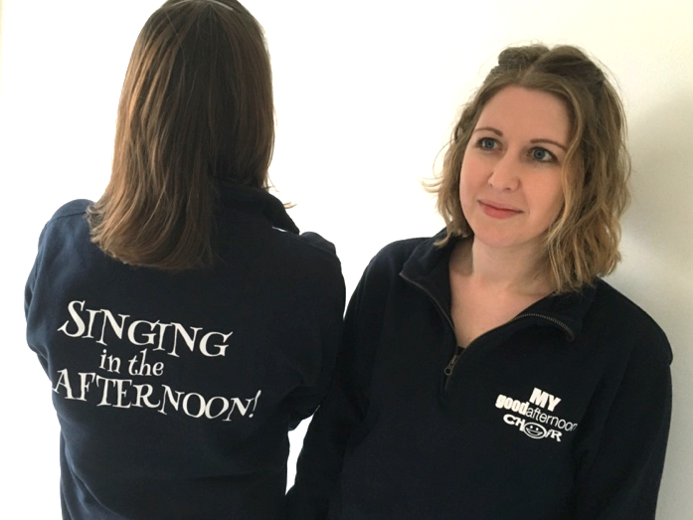
£29.00(includes £3.50 p&p)

Your Name: …………………………..…………………………..…………………………..…………………………..……………..

Tel No: …………………………..………………………Email: …………………………..……………………………………………..

Address & postcode: …………………………..…………………………..…………………………..…………………………….

…………………………..…………………………..…………………………..………………………………………………………………

Please state which Good Afternoon Choir you attend: ………..…………………………..…………………………..

Number of sweatshirts required: (the sweatshirt is Navy Blue)

SIZE (please tick/indicate how many of each size in the box)

Small (36”) Medium (40”) Large (44”) XL (48”) 2XL (52”)

PAYMENT CAN BE MADE VIA CHEQUE OR BACS for £29.00 per jumper (which includes £3.50 p&p)

Please tick if you will make payment via BACS or CHEQUE
(*bank details given below)

I enclose a cheque for a total £………………… (£29.00 per jumper which includes p&p)
cheques payable to: The Good Afternoon Choir

PAYMENT IS DUE WITH YOUR FORM – all cheques payable to: The Good Afternoon Choir or payment can be made direct via *BACS to the following account:
Acc. No: 55609007 Sort Code: 60-14-24 Reference: Your name & Sweatshirt
Returning your form: Please email your completed form to choirs@grenvillemusic.co.uk
or post direct to: The Good Afternoon Choir, Unit 7, Fourth Avenue, Westfield Ind. Estate, Radstock, BA3 4XE

